Name:
Plan Deposit:

Plans and Specs Order Form

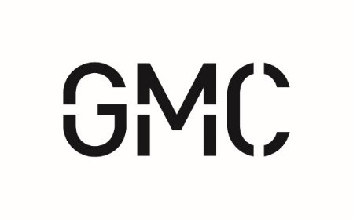
Sidewalks along School Drive and SR-77 in Southside.

$20 – digital and/or printed, Non Refundable

Pre-Bid Conference:

N/A
Bid Opening: Tuesday, July 21, 2026
GMC Project No.: THUN240001

Requestor Information (Check one):
Contractor Sub-Contractor Supplier/Mfr. Plan Room

Contact Name: Company: Address (No PO Box): City, State Zip: Phone: Email: License # : Choose one or more of the following:
Printed set mailed (via UPS) Digital set (via skysite.com)

Make check payable to:
Brooke Gibson
GMC
2660 Eastchase Lane #200, Montgomery, AL 36117

Additional comments or requests:

*Return completed form with a scanned copy of plan deposit check to
Brooke.gibson@gmcnetwork.com

